## Datetime sort modifier

This modifier is needed in order to be able to set the Task execution time. For example, you need the task to be available from November 1, 2022 to December 1, 2022. Or is it still possible to make tasks available after a while, after completing the previous ones. If it wasn't clear, we'll figure it out now.

## Simple Chain with Datetime Sort

The idea of this simple chain is that the user will first write the name of the movie that he will be watching now, and then, say in 2 hours, he will receive a task where he will need to write a review about this movie.

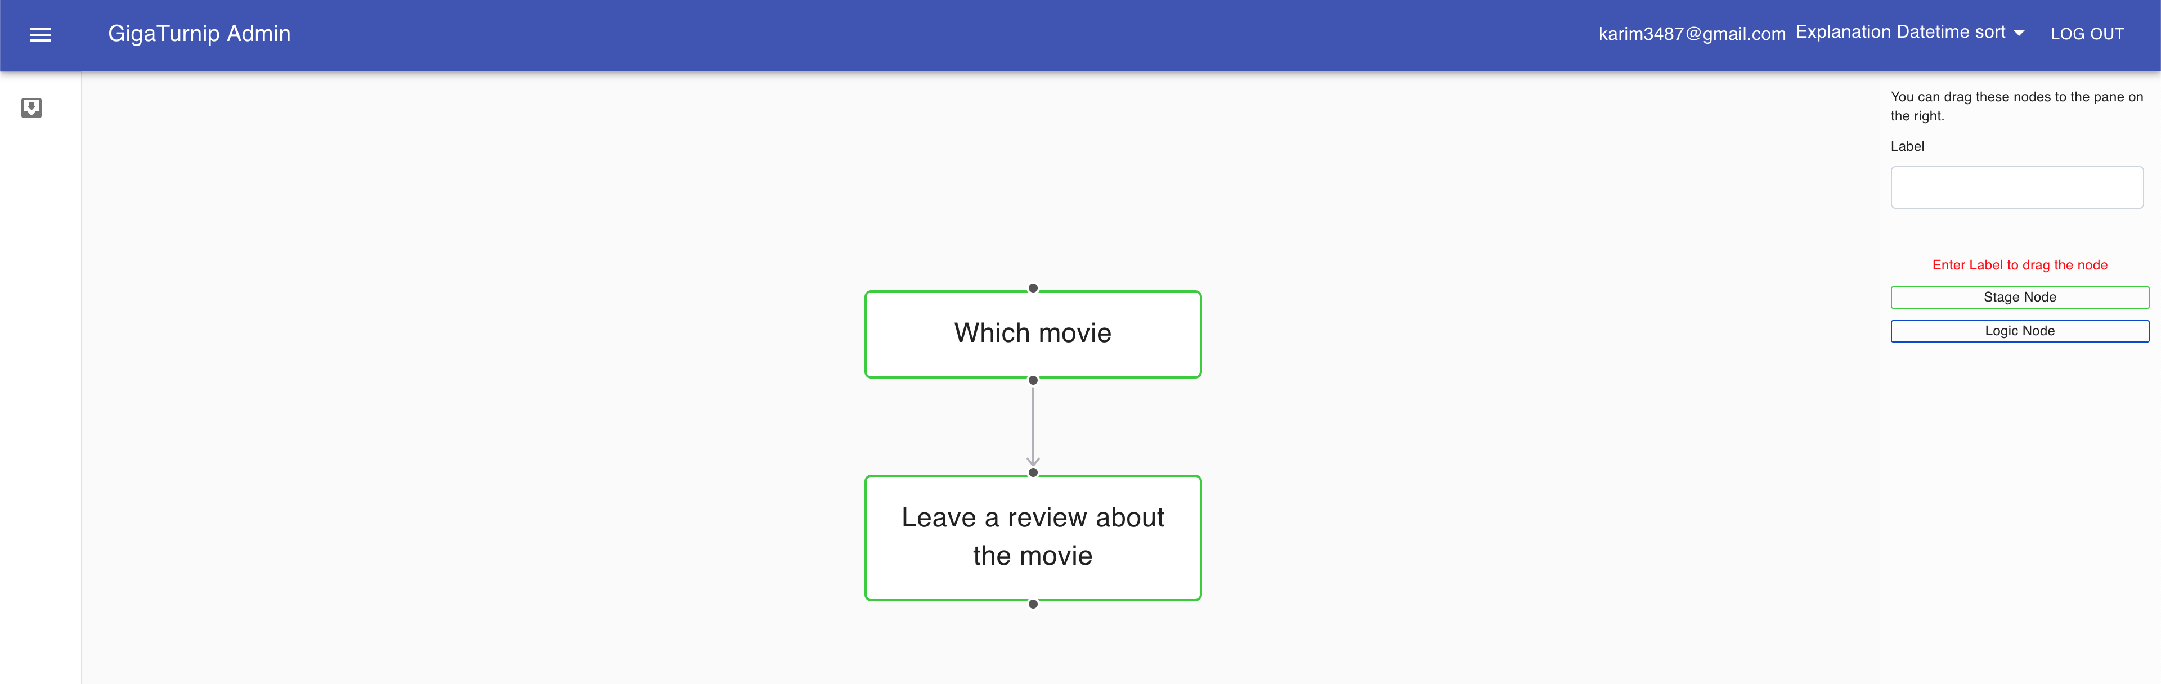

In order for everything to work correctly, you need to go to the admin panel and configure the Datetime sort modifier.

## Datetime sort fields

Datetime sort modifier has 5 fields, now we will analyze each of them:

**stage:** the stage whose tasks need to be sorted by time.

**start_time:** the time when the task should open

**end_time:** the time when the task should close

**how_much:** how long to open the task

**after_how_much:** how long does it take to open a task

Note: you cannot use the fields "start_time", "end_time" together with "how_much", "after_how_much". They have different logic.